Report---Assignment3

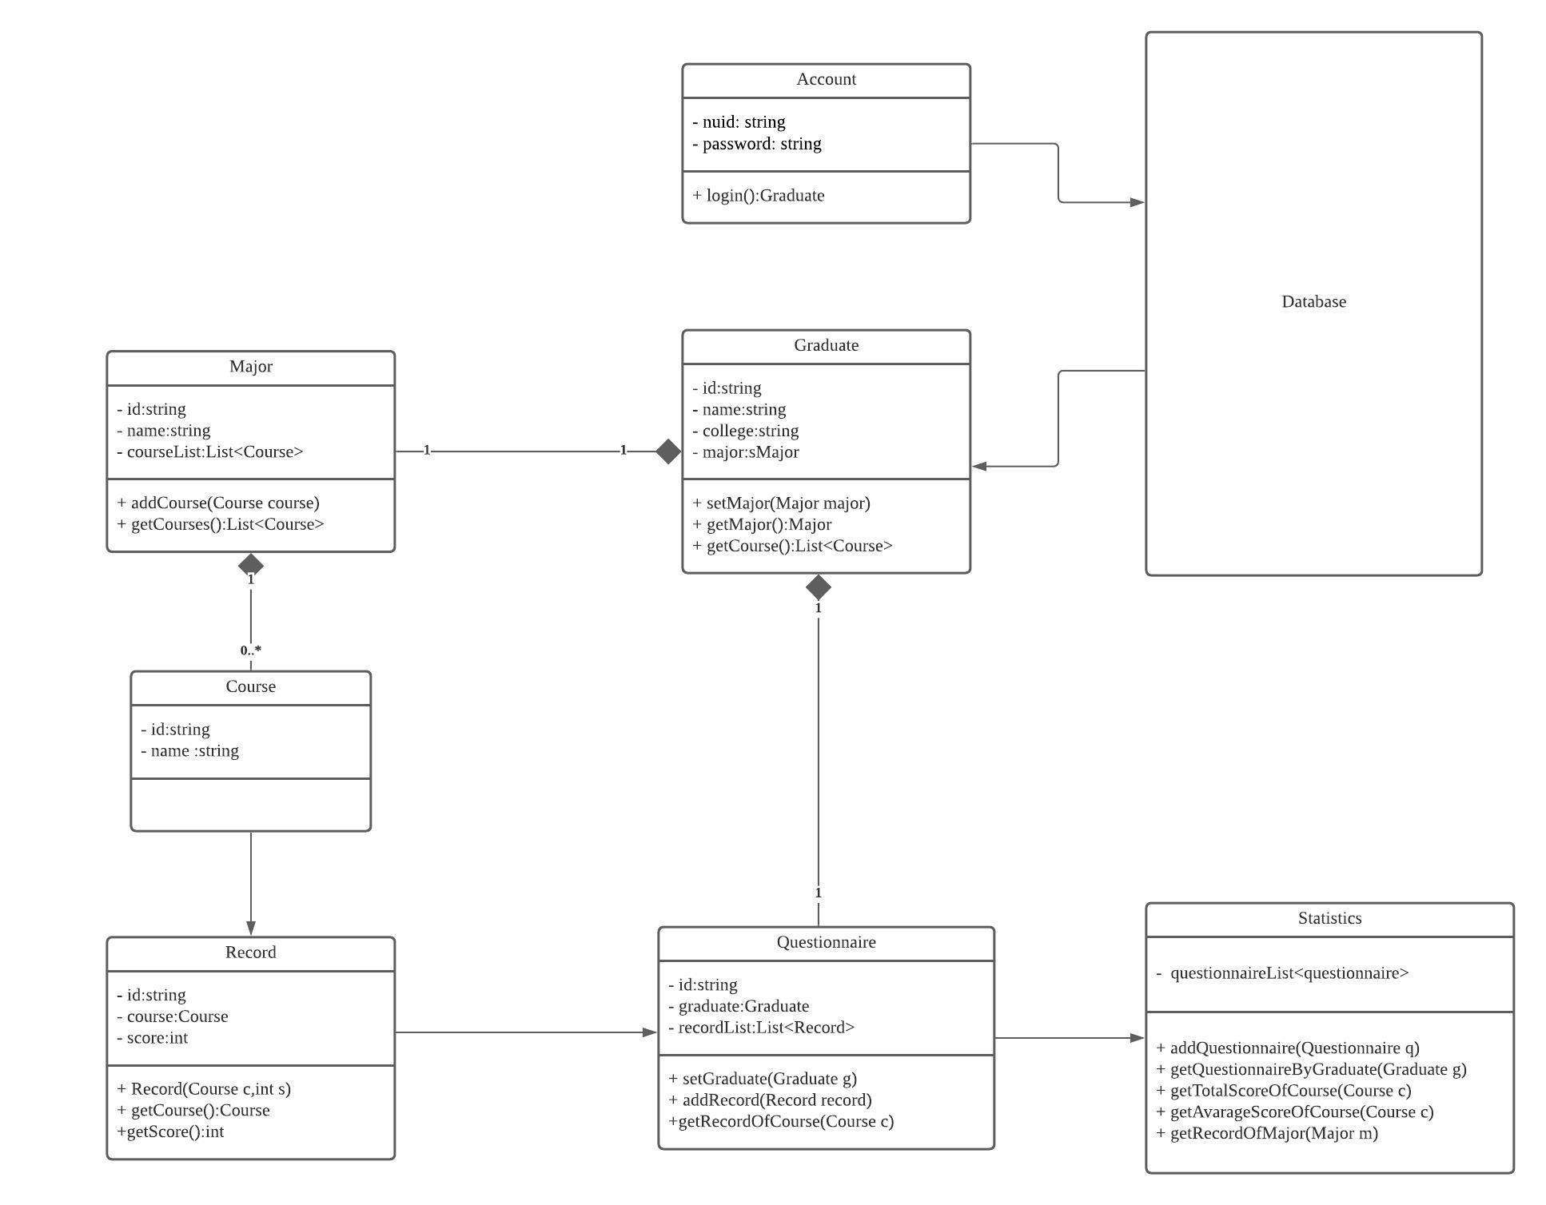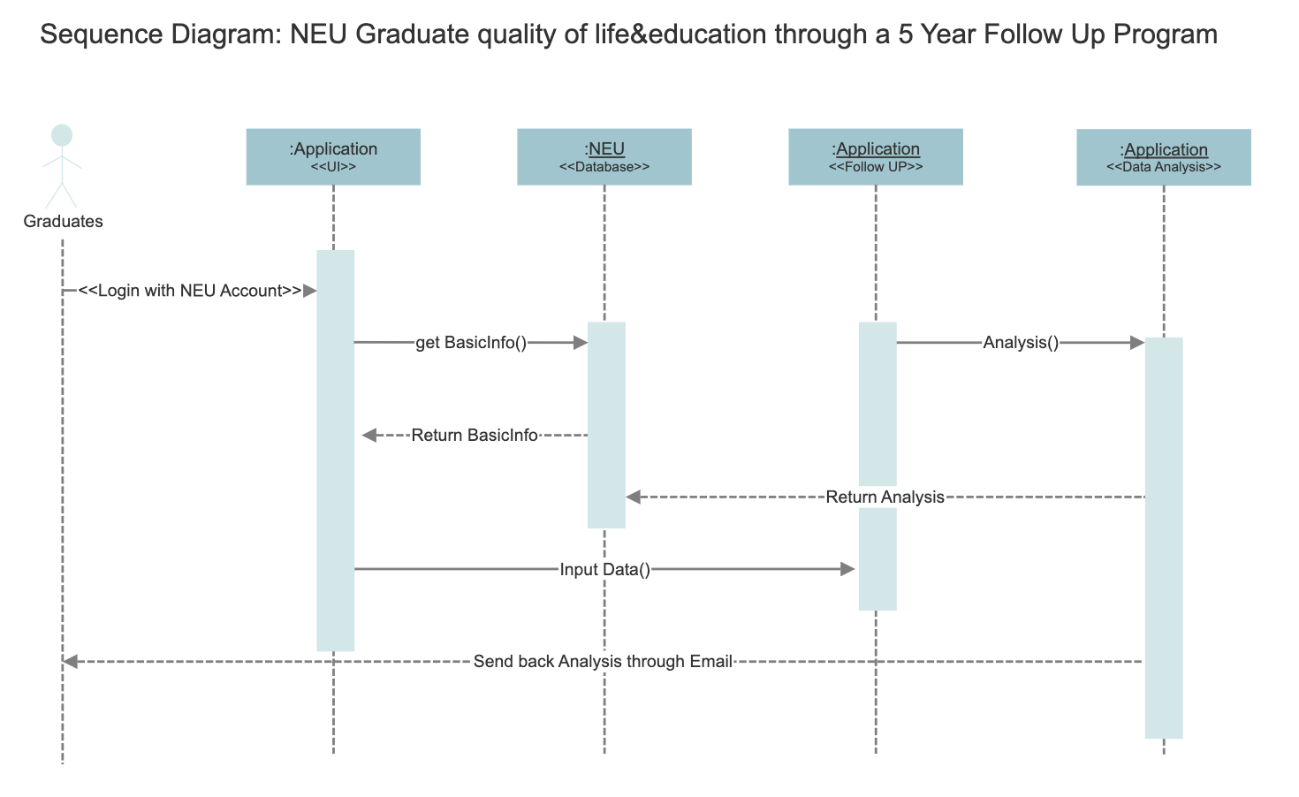

In this program, we are going to design a system that will collect information from graduated students for a five years period, ask them about their feelings about the classes they have taken, the quality of their current life and whether it played an important role for their promotions from work. After receiving these data, we will deploy a “data analysis” method to determine which courses are helpful to improve our students’ future career and which are not. It will create a statistical chart and send it to NEU in order to improve our course.

Since University has different majors and students end up in different jobs even when some of them took exactly the same classes, so everything we make analysis on is based on their jobs, interviews and promotions instead of majors. Graduates are allowed to select their most favorable classes from the class they have taken and grade them scale from 1 to 10. Analysis will be made based on this information.

For GUI, you will need to enter your NUID and password to login at Login Interface, then we will ask for an agreement to get your basic information (name, Year of graduation, College, Major, Instructor and the Major course list. After getting that, we ask a few questions to grade each course, and determine if the course is helpful. When the survey is done, these data will be transferred into our “data analysis” method to make data analysis and output different charts and statistical data for us to understand the quality of every course. Finally, it will send back those information to NEU for each department in order to help the university and the board to make decisions that will improve the quality and contents of the classes. To understand student’s circumstances better in order to help students gets ready for different challenges they are going to face at their future career.

